**Jaypee Institute of Information Technology, Noida**

DEPARTMENT OF COMPUTER SCIENCE & ENGINEERING AND INFORMATION TECHNOLOGY

  
  
  
**Project Title:** ZipWizard

|  |  |
| --- | --- |
| **Enrollment No.** | **Name** |
| 992401030360 | Pragnya Khandelwal |
| 992401030361 | Pratishtha Singh |
|  |  |
|  |  |

Course Name: Software Development Fundamental

Course Code: 24B15CS111

Program: B. Tech. CSE\IT\ECE

1st Year 1st Sem

**2024 - 2025**

**ZIP WIZARD - file handling and compression system**

**Flow – Chart**

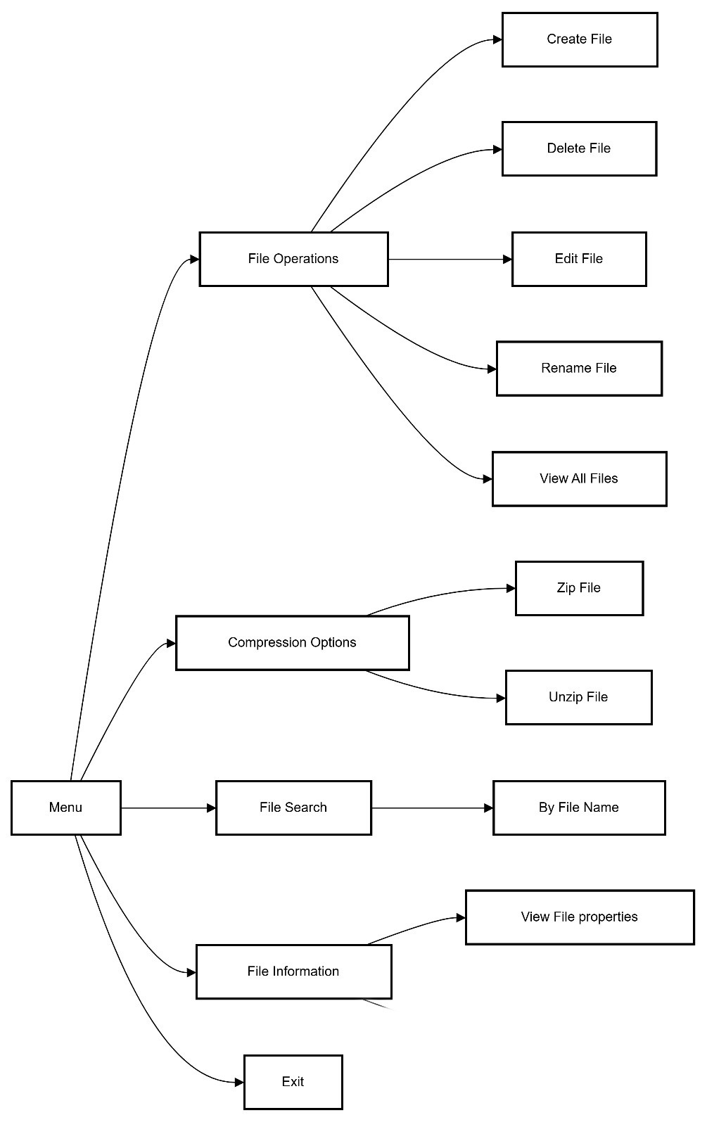

**INTRODUCTION**

**Aim:**To prepare a File Handling and Compression System.

**About the project:**

This project, **ZipWizard**, provides a comprehensive solution for handling file operations and implementing basic file compression techniques. The system allows users to create, edit, read, rename, delete, list, search and manage files through an intuitive command-line interface. These operations will be done with the help of different file handling functions in C. In addition to these essential file operations, the system integrates file compression and decompression using two prominent algorithms: **Deflate and Inflate** which is a combination of **Huffman Coding** and **LZ77 compression**.

**Features of the Project:**

**File Operations**:

* **Create**:
  + Users can create new text files by specifying a filename and entering initial content. The system ensures that the filename is valid and does not already exist to avoid overwriting.
* **Read**:
  + Users can read and display the contents of existing text files. The system handles reading line by line or in chunks to accommodate large files and provides options for viewing file metadata, such as size and last modified date.
* **Edit**:
  + Users can modify the content of existing text files, appending to the current content. A simple text editor interface allows users to navigate and make changes easily.
* **Rename**:
  + Users can rename files, with checks to prevent name collisions and to ensure valid naming conventions. Confirmation prompts help avoid accidental changes.
* **Delete**:
  + Users can delete files, with a confirmation step to prevent accidental deletions. Feedback is provided on the success or failure of the operation.
* **Manage**:
  + The system offers a file management utility that lists all text files in the current directory, displaying details like file names, sizes, and last modified dates. Users can sort and filter this list based on various criteria, enhancing usability.

**Searching Files**:

* **Search Functionality**:
  + Users can search for specific text files in the directory by name or by using keyword searches within file contents.
  + The search results display matching files, including relevant details, helping users quickly locate desired files.

**File Properties**:

* **Display File Properties**:
  + The system provides functionality to display detailed properties of a selected file. This includes:
    - **File Name**: The name of the file.
    - **File Size**: The size of the file in bytes.
    - **Creation Date**: The date and time when the file was created.
    - **Last Modified Date**: The date and time when the file was last modified

**Listing Files**:

* + Users can view file attributes, such as date created, and last modified date, making it easier to manage and organize files.

**Compression and Decompression**:

* **Deflate Algorithm**:
  + The system implements the Deflate algorithm, combining LZ77 and Huffman coding for efficient compression. Users can specify compression levels to balance speed and efficiency.
* **Inflate Algorithm**:
  + Decompression functionality restores compressed files to their original state, decoding Huffman-coded data and reconstructing text using LZ77 references.

**User Interface**:

* **Command-Line Interface**:
  + An intuitive, menu-driven command-line interface guides users through operations, with context-sensitive help available for each function.

**File Type Support**:

* **Text Files**:
  + The project specifically handles .txt files, ensuring optimal performance for text-based data.

**Error Handling**:

* Comprehensive error checking is implemented for all operations, providing meaningful feedback to users and enhancing robustness.

**Documentation and Help**:

* Detailed documentation outlines how to use each feature, with built-in help commands accessible directly from the interface.

**Performance Optimization**:

* Performance benchmarks for compression and decompression speeds may be included, along with customizable performance settings.

**C - Programming Concepts to be used are:**

**File Handling**: create and manipulate file streams, allowing for operations like opening, reading, writing, and closing files

* **Arrays:** Arrays are used to store character data, frequency counts for Huffman coding, and to maintain lists of files for management and searching.
* **Pointers:** providing flexibility in memory management, enabling efficient data structure manipulation, and allowing direct modification of variables through function parameters.
* **Structures**: Custom structures may be defined to manage file metadata and compression data.
* **Dynamic memory allocation**: Used for allocating and deallocating memory for file contents, Huffman trees, and other structures at runtime, allowing flexibility in handling variable-sized data.
* **User-defined Functions**: The project is organized into functions that handle specific tasks, promoting code reusability and clarity.
* **String Manipulation:** Functions from <string.h> are used for handling strings, including filenames and file contents.
* **Standard Libraries:** Libraries like <stdio.h>, <stdlib.h>, <string.h>, etc. are used for common functions and types needed for file handling, memory management, string manipulation, and time-related operations
* **Error Handling**: The project checks return values of file operations to handle errors efficiently.

**DESIGN OF THE PROJECT**

The design of the project includes the main menu with sub-options that allow users to navigate and perform tasks. Below is the flowchart for better visualization:

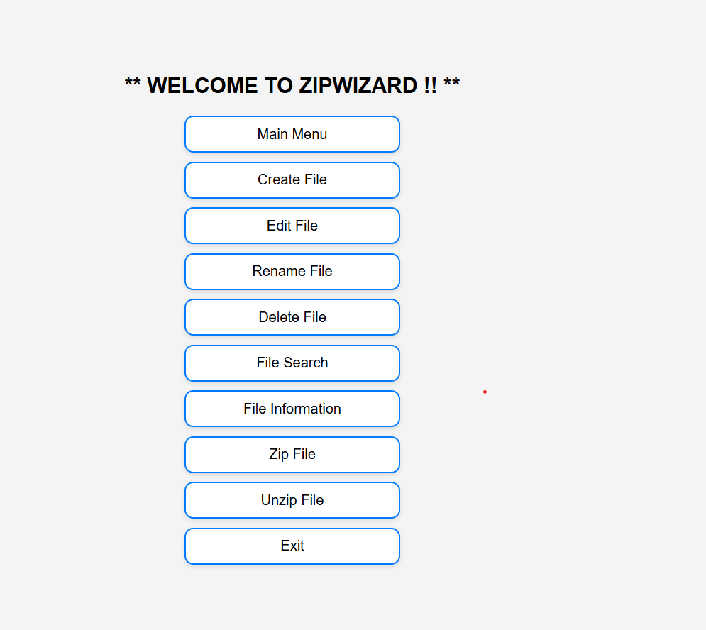

**1. System Overview**

**ZIPWIZARD** is a file management tool that allows users to perform the following operations:

* **File Operations**: Create, Edit, Rename, Delete, and View Files.
* **Compression Operations**: Zip and Unzip files.
* **File Information**: Display file metadata, including file name, creation date, and last modified date.
* **File Search**: Search for files by name or content.

The system will be implemented in **C**, and it will handle text files (.txt files). It will include simple file compression (using the **Deflate** and **Huffman Coding** algorithms).

**2. User Interface Design**

The interface will be **menu-driven** and will run in a terminal or command-line window. The user will interact with the program by selecting options through the menu.

**Main Menu Flow:**

* **Start** → **Main Menu**
* **Main Menu** will present the user with several options for performing actions on files.
* After completing a task, the user will return to the **Main Menu** until they decide to exit.

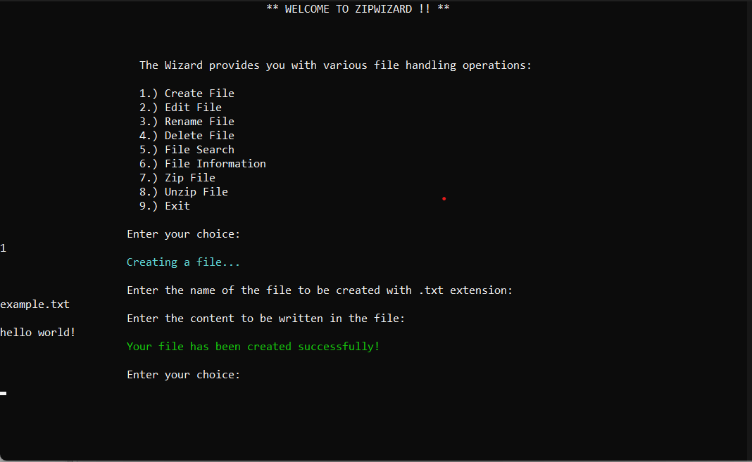

**3. Functionalities and Features**

The system will have the following core functionalities:

**A. File Operations:**

1. **Create File**:
   * Users can create a new file and add content to it.
   * The system will prompt for a filename and ensure it doesn't already exist to avoid overwriting.
2. **Edit File**:
   * Users can open an existing file and edit its contents.
   * The user can either replace the file's content or append new content to the file.
3. **Rename File**:
   * Users can rename an existing file.
   * The system will check for file name collisions and ensure the name is valid.
4. **Delete File**:
   * Users can delete a file, with a confirmation prompt to prevent accidental deletion.
5. **View All Files**:
   * Users can view a list of all files in the current directory, displaying their names, sizes, and last modified date.

**B. File Search:**

* Users can search for files by their **filename** or by searching for specific content within the files.

**C. File Information:**

* Users can display file properties such as:
  + **File Name**
  + **File Size**
  + **Creation Date**
  + **Last Modified Date**

**D. Compression Operations:**

1. **Zip File**:
   * Compress a file using the **Deflate Algorithm** (a combination of **Huffman Coding** and **LZ77**).
2. **Unzip File**:
   * Decompress a zip file back to its original state using the **Inflate Algorithm** (the inverse of Deflate).

**E. Exit:**

* Exits the program.

**4. Algorithm Design**

**A. File Compression (Deflate Algorithm)**

* **Huffman Coding**: Used to create a frequency table and then build a binary tree for encoding file data.
* **LZ77 Compression**: Uses sliding windows to replace repeated strings with references to earlier parts of the data.

**B. File Decompression (Inflate Algorithm)**

* **Huffman Decoding**: Reverses the Huffman coding process to restore the original data.
* **LZ77 Decompression**: Restores the file by reversing the sliding window references.

**C. File Handling in C**

* File operations will use the standard **C library** functions such as:
  + fopen() for opening files.
  + fread() and fwrite() for reading and writing data.
  + fclose() for closing the file.
  + remove() for deleting files.

**D. Searching Files**

* Searching will be done by scanning the file contents line by line or using file metadata like name or modification time.
  + - 1. **Error Handling and Validation**

The system will include error handling for:

* Invalid file names (e.g., names with special characters).
* File not found (when editing, renaming, or deleting).
* File access errors (e.g., permission issues).
* Compression or decompression errors.
* User input validation (to ensure valid menu selection).

**IMPLEMENTATION DETAILS**

In ZipWizard, the project is structured to separate the functionality into individual C files and header files for modularity, reusability, and easier maintenance. The header files (.h) define the function prototypes, data structures, and constants, while the C files (.c) contain the implementation of these functions and other logic.

The **ZipWizard** project follows a modular architecture, where different tasks such as file compression, decompression, renaming, searching, editing, and utility functions are handled by individual modules. This modular approach ensures that each component is self-contained, making it easier to maintain, debug, and extend the functionality in the future.

Here’s an overview of how the modules come together in the **ZipWizard** project:

**1. Main Program (main.c)**

This is the entry point where the user interacts with the program. It prompts the user for input and invokes the appropriate functions from the different modules (e.g., compression, decompression, renaming, etc.).

**Responsibilities:**

* Displays the menu to the user.
* Collects user input (e.g., which action to perform).
* Calls functions from the various modules (Compression, Decompression, File Editing, etc.) based on the user's choices.

**2. Compression Module (zipFile.c)**

This module contains the functionality for compressing files. It uses different compression algorithms, such as **LZ77** or **Huffman encoding**, to convert files into a compressed format.

**Key Functions:**

* **lz77Compress()**: Implements the LZ77 compression algorithm. It reads the input file, identifies repeated substrings, and compresses the data using a sliding window mechanism.
* **zipFile()**: This function can be used to handle the compression process, including writing the compressed data to a new file.

**3. Decompression Module (unzipFile.c)**

Handles the decompression of files that were compressed by the **zipFile.c** module. It supports decompression algorithms like **LZ77** and **Huffman coding**.

**Key Functions:**

* **lz77Decompress()**: This function decompresses files using the LZ77 algorithm, where compressed data (offsets, lengths, characters) is processed and the original file is reconstructed.
* **unzipFile()**: This function is used to handle the decompression process, reading the compressed file and writing the decompressed output.

**4. File Editing Module (editFile.c)**

This module provides the functionality for users to interact with text files. It allows users to open, modify, and save changes to files. It supports appending data to files and reading from them.

**Key Functions:**

* **editFile()**: This function allows users to open a file and make changes to it, such as adding new content.

**5. File Search Module (searchFile.c)**

This module allows users to search for files by their name or keyword. The user can search for files in the current directory that match a given pattern or contain a specific keyword.

**Key Functions:**

* **searchfile()**: Allows the user to search for files by name or by keyword. It uses the Windows API (FindFirstFile and FindNextFile) to search for files matching the specified criteria.

**6. File Rename Module (renameFile.c)**

This module provides functionality for renaming files. It checks if the file exists and ensures that the new name follows specific rules (e.g., file names should end with .txt).

**Key Functions:**

* **renamefile()**: Prompts the user for a file name to rename and checks if the file exists. It then asks for a new file name and performs the renaming operation using the rename() function.

**7. Utility Functions Module (Utils.c)**

The **Utils.c** module contains helper functions that are used across the entire application. These functions handle tasks like input validation, printing formatted messages, and basic file operations.

**Key Functions:**

* **zwPrint()**: A utility function for printing messages to the console. It allows the program to output messages with different severity levels (e.g., INFO, ERROR, SUCCESS).
* **terminalSize(int width,int height)**: sets the size of the terminal window and disables resizing or maximizing on a Windows platform.

**8. View File Information Module ( fileInfo.c):** The function relies on Windows-specific API calls (GetFileAttributesEx, GetFullPathName, FileTimeToSystemTime, etc.), and outputs information about the file through the zwPrint() function, which seems to be a custom logging or display function.

**Key Functions:**

* fileInfo(): Prompts the user to enter a file name and then retrieves and displays various attributes and timestamps of the specified file

**9. Error Handling**

Error handling is essential to the **ZipWizard** project. Several layers of validation and checks are used to ensure that each file operation and user input is valid.

**Error Handling Strategies:**

* **File Existence Check**: Each file operation (reading, writing, or editing) first checks if the file exists, if it can be opened, and if the operation succeeds.
* **Input Validation**: User inputs (e.g., file names, content) are validated for correctness before performing operations on them.
* **Error Messages**: If something goes wrong, clear and descriptive error messages are shown to the user. These are formatted using the zwPrint function with appropriate labels for error levels (e.g., ERROR_FILE, INFO, SUCCESS).

**10. File Handling**

File handling is performed carefully to ensure that the program does not cause data corruption or loss during its operations. Various checks are performed during file reading and writing operations.

**File Operations:**

* **Reading**: Files are opened using fopen() in appropriate modes (r for reading, a for appending, etc.). We also make sure to close files using fclose() to free resources.
* **Writing**: Data is written to files using fprintf() for appending content. We validate the file paths and names before attempting to write to them.
* **Buffered I/O**: When dealing with large files, fgets() and other buffered reading functions are used to handle the input safely.

**11. Algorithm Choice**

The core algorithm used in **ZipWizard** is the **LZ77** compression algorithm, which is effective for compressing text-based files. It works by finding repeated substrings and encoding them as references to previous occurrences within a sliding window of the data.

**LZ77 Compression:**

* **Sliding Window Mechanism**: The algorithm uses a window to store previously seen data. If the same sequence of characters is found within the window, the data is replaced with a reference to the earlier part of the string (offset and length).

**File Structure:**

* The compressed files store metadata such as the dictionary and offsets. This metadata helps in efficient decompression.

**12. Design Patterns**

The **ZipWizard** project adheres to several key design principles:

**Modularity:**

Each task (compressing, decompressing, editing) is handled by its own dedicated module. This makes the code more maintainable and reusable.

**Separation of Concerns:**

Each module is responsible for a specific task. This allows modifications in one area (e.g., compression) without affecting other parts of the program (e.g., file editing).

**Error Handling Strategy:**

The program uses early returns in case of errors, which keeps the control flow clean and avoids deep nesting of conditional statements.

**13. User Interface**

The user interface is text-based, designed for simplicity and ease of interaction. Users are presented with options through prompts and asked to provide the necessary inputs (file names, keywords, etc.).

**User Interaction:**

* **Prompts**: The program uses clear and concise prompts to guide the user through various operations.
* **Feedback**: The program provides informative messages after each operation (e.g., success, error messages).

**Inflate and Deflate Algorithms: Overview, Limitations, and Drawbacks**\*

The Inflate and Deflate algorithms are widely used in compression and decompression techniques, notably in formats like ZIP and GZIP. These algorithms are based on the LZ77 (Lempel-Ziv 1977) algorithm and the Huffman coding scheme. While they provide effective compression, they come with certain limitations and drawbacks depending on file type, size, and other factors. Below is an explanation of these algorithms, followed by their drawbacks and limitations.

Overview of Inflate and Deflate Algorithms:

1. Inflate Algorithm:

- The Inflate algorithm is a decompression algorithm used to reverse the process of the Deflate algorithm.

- It is commonly used in formats like GZIP, ZIP, and PNG to decompress files that have been compressed using the Deflate algorithm.

- It uses LZ77 compression, which replaces repeated strings with references to previous occurrences, and *Huffman coding*, a form of entropy coding to further compress data.

2. Deflate Algorithm:

- The Deflate algorithm is a lossless data compression method that combines LZ77 and Huffman coding.

- LZ77 works by identifying duplicate strings in the data and replacing them with shorter references to earlier occurrences. Huffman coding is used to assign shorter codes to more frequent characters and longer codes to less frequent characters.

- Deflate is widely used in formats such as GZIP, ZIP, and PNG due to its efficient balance between compression ratio and speed.

Drawbacks and Limitations of Inflate and Deflate Algorithms:

While the Inflate and Deflate algorithms are highly efficient for many general-purpose compression tasks, they do have some limitations and drawbacks, especially when applied to different types of data and file sizes. Here are the key issues:

1. File Size and Compression Ratio:

- Limitations with Large Files:

- Deflate may struggle with very large files (several GB or more), as the algorithm is designed for a block-based compression approach. In such cases, the compression process may become slow, and memory usage could increase significantly.

- The compression ratio may degrade for files that are already compressed or files that contain little redundancy (e.g., encrypted or highly random data).

- For small files, the overhead of compression (metadata, block headers) might make compression less efficient, resulting in negligible or even larger file sizes after compression.

- The compression and decompression process get successfully executed when the file contains a single word or unique characters with single spaces

- Inefficiency on Highly Compressed Files:

- Files that have already been compressed (such as video files, images in JPEG format, etc.) generally do not benefit much from Deflate compression because they lack redundancy. The compression could even increase the file size slightly due to the additional metadata and block structures.

2. Compression Speed vs. Ratio Tradeoff:

- Time-Consuming for High Compression Ratios:

- While Deflate generally balances speed and compression ratio well, it does not achieve the highest possible compression ratios compared to more complex algorithms (e.g., Brotli or LZMA). To achieve better compression ratios, Deflate can become slower, and the decompression time can also increase.

- The algorithm prioritizes speed, and while this is advantageous in many applications (e.g., web compression), it may not be the best choice when maximum compression is needed.

3. Algorithm Complexity and Memory Usage:

- Memory Limitations:

- The LZ77 part of Deflate uses sliding window buffers to store past data, and its performance can be limited by available memory. For very large files, the sliding window can cause memory issues, especially when working with low-resource systems.

- Although Deflate is not as memory-intensive as some other compression algorithms (e.g., LZMA), handling very large files can still lead to increased memory usage.

- Slow Decompression for Complex Files:

- While Deflate is generally fast during decompression, for files with many small blocks (such as those that consist of a lot of short strings or fragmented data), decompression can become slower compared to more modern algorithms like Brotli, which is optimized for such cases.

Limited Efficiency with Text Data:

- Text-based files (e.g., XML, JSON, CSV) that contain repetitive patterns will benefit from Deflate’s compression. However, for highly structured data or data that lacks redundancy, the Deflate algorithm may struggle to achieve significant compression gains.

5. Security Concerns (For Some Implementations):

- Potential Vulnerabilities:

- While Deflate itself is secure, certain file formats that use the algorithm (e.g., ZIP or GZIP) can introduce vulnerabilities related to data integrity or padding attacks. Improper handling of compressed data can lead to issues such as zip bomb attacks (where an intentionally maliciously crafted file is inflated to an excessive size during decompression).

- Security considerations become more important in file formats that implement **Deflate** compression, especially when dealing with untrusted files.

6. Lack of Advanced Features in Some Implementations:

- Lack of Dictionary Support:

- Unlike more advanced compression methods like **LZMA** or **Zstandard**, **Deflate** lacks support for dictionary-based compression over multiple files or across file streams. This means that Deflate is often limited to compressing one file at a time and cannot leverage broader data contexts as efficiently as other algorithms.

Summary of Drawbacks and Limitations:

- File Size and Compression Efficiency: Not suitable for already-compressed files or files with little redundancy (e.g., encrypted files, media files).

- Speed vs. Compression Ratio Tradeoff: Compression speed can be high, but for higher compression ratios, the process becomes slower.

- Memory Usage and Complexity: The algorithm may struggle with large files or files that require a large sliding window.

- Security Risks: Some implementations of **Deflate** may be vulnerable to certain types of attacks, especially if not properly secured.

- No Support for Advanced Features: Lack of dictionary support or multi-file compression in some implementations.

While the **Inflate** and **Deflate** algorithms are efficient and widely used for compression and decompression, they do have limitations when dealing with certain file sizes, types, and performance requirements. They work best with files containing repetitive data and moderate sizes. However, for more complex use cases requiring higher compression ratios or specialized optimizations, newer compression algorithms like **Brotli** or **Zstandard** might provide better results. Additionally, the absence of quantum computing threats today makes **Deflate** suitable for most applications, but future-proofing with more advanced encryption techniques might be necessary for long-term security and efficiency.

**BIBLIOGRAPHY**

**Microsoft Developer Network (MSDN)**. (2024). *Windows API Functions*. Microsoft. Retrieved from: <https://docs.microsoft.com/en-us/windows/win32/api/>

* MSDN is the primary resource for Windows system programming. It provides the documentation for functions like SetConsoleWindowInfo, GetConsoleWindow, SetWindowPos, and GetFileAttributesEx, which are used in ZipWizard to manipulate the console window and file attributes.

**Wikipedia Contributors**. (2024). *LZ77 Compression*. Retrieved from: <https://en.wikipedia.org/wiki/LZ77_and_LZ78>

* + This page provides a high-level overview of the LZ77 algorithm, which forms the core of the compression technique likely used in ZipWizard.

**API Documentation**:

* **Microsoft Docs**. (2024). *GetFileAttributesEx Function*. Retrieved from: <https://learn.microsoft.com/en-us/windows/win32/api/fileapi/nf-fileapi-getfileattributesexw>
  + This documentation provides details about the GetFileAttributesEx function, which is used in the ZipWizard project to retrieve file attributes such as creation, modification, and access times.
* **Microsoft Docs**. (2024). *SetConsoleWindowInfo Function*. Retrieved from: <https://learn.microsoft.com/en-us/windows/win32/api/winuser/nf-winuser-setconsolewindowinfo>
  + This page provides details about the SetConsoleWindowInfo function, used in ZipWizard to control the size of the console window.

**Stack Overflow**. (2024). Questions related to *SetWindowPos* and Windows Console Programming. Retrieved from: <https://stackoverflow.com/questions/>

* + - A community-driven forum where many programming questions related to Windows-specific APIs and console window manipulation can be found.

**REFERENCES**

**Research Papers and Articles**:

* **Huffman, D. A.** (1952). *A Method for the Construction of Minimum-Redundancy Codes*. Proceedings of the IRE, 40(9), 1098–1101. https://doi.org/10.1109/JRPROC.1952.273898
  + This paper introduces the Huffman coding algorithm, which is often used in file compression tasks. Although ZipWizard focuses on LZ77, Huffman coding is also an important concept in compression.
* **Ziv, J., & Lempel, A.** (1977). *A Universal Algorithm for Sequential Data Compression*. IEEE Transactions on Information Theory, 23(3), 337–343. https://doi.org/10.1109/TIT.1977.1055714
  + This paper presents the LZ77 algorithm for data compression, which serves as a foundation for the compression techniques in ZipWizard.